
Company
Logotype

Cone Beam Computed Tomography- Report



Porur Dental X-rays & CBCT

Patient Name : Mr. Baskar | Date of Report : 01.07.2024
Age/ Gender : 52 years/ Male | Region of Interest : CBCT Sectional Mandible
Referring doctor: Dr. M. Balamurali Sai | Indication : Implant assessment
Clinical Notes: Nil
PATIENT INFORMATION

CBCT- Sectional Mandible provided
CBCT – IMAGE DETAILS

RADIOGRAPHIC INTERPRETATION

- Complete loss of crown and root structure in relation to 36, 37.
- The alveolar bone in relation to 36, 37 is present with normal trabecular pattern.
- In 38, presence of hyperdense crown structure and restorative material involving the pulp canal upto the apical region of the roots is evident.

IMPLANT ASSESSMENT

 | 36 region | 37 region
Sub-Crestal (in mm) | 5.73 | 5.79
Mid- Crestal (in mm) | 7 | 7.29
Distance between alveolar ridge and the inferior alveolar nerve canal (in mm) | 15.07 | 16.15
Distance between alveolar ridge and the inferior border of mandible (in mm) | 27.38 | 25.87

RADIOGRAPHIC IMPRESSION

- Partially edentulous region: 36, 37.
- Root canal treated tooth: 38.

Kindly correlate with clinical findings


IMAGES FOR REFERENCE

RECONSTRUCTED PANORAMIC VIEW
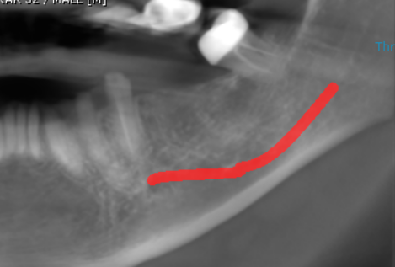

3-DIMENSIONAL VIEW

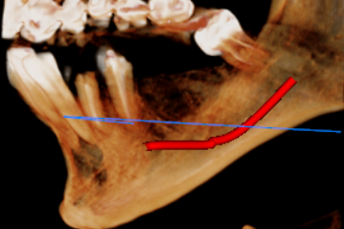

CROSS SECTIONAL VIEW

36 region | 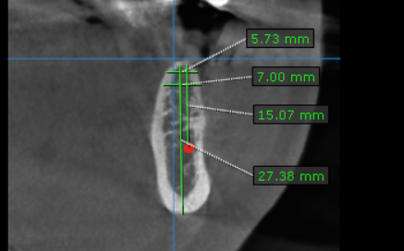
37 region | 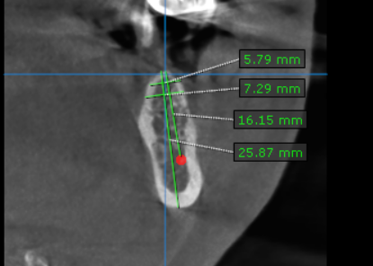

**** End of report ****

